Irregular Verbs

🔹 What is Irregular Verbs
# Source: AI Source: Provided by: [Data Path: Persons Table -> ID Column: 1, Name_En Column: Motasem Essam] -> From: [Chatgpt (GPT-4-turbo)] on [7/27/2025]
An irregular verb is a verb that forms its past tense and past participle in an unpredictable or unique way, not by simply adding -ed or -d.

✅ Definition:
# Source: AI Source: Provided by: [Data Path: Persons Table -> ID Column: 1, Name_En Column: Motasem Essam] -> From: [Chatgpt (GPT-4-turbo)] on [7/27/2025]
An irregular verb is a verb that does not follow the usual "-ed" pattern when changing into the past tense or past participle.

🔁 How It’s Different from Regular Verbs:
# Source: AI Source: Provided by: [Data Path: Persons Table -> ID Column: 1, Name_En Column: Motasem Essam] -> From: [Chatgpt (GPT-4-turbo)] on [7/27/2025]
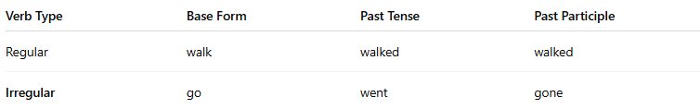
Verb Type | Base Form | Past Tense | Past Participle
Regular | walk | walked | walked
Irregular | go | went | gone
🟨 You must memorize irregular verbs, because their forms vary and don’t follow a rule.

📚 Examples of Common Irregular Verbs:
# Source: AI Source: Provided by: [Data Path: Persons Table -> ID Column: 1, Name_En Column: Motasem Essam] -> From: [Chatgpt (GPT-4-turbo)] on [7/27/2025]
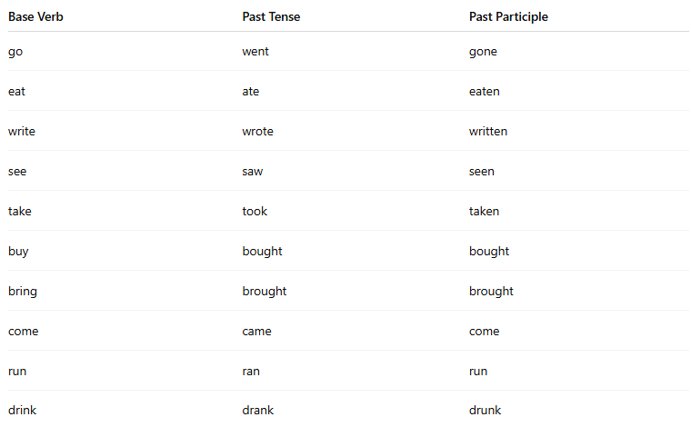
Base Verb | Past Tense | Past Participle
go | went | gone
eat | ate | eaten
write | wrote | written
see | saw | seen
take | took | taken
buy | bought | bought
bring | brought | brought
come | came | come
run | ran | run
drink | drank | drunk

🧠 Irregular Verb Patterns (Some Have Similar Patterns):
# Source: AI Source: Provided by: [Data Path: Persons Table -> ID Column: 1, Name_En Column: Motasem Essam] -> From: [Chatgpt (GPT-4-turbo)] on [7/27/2025]
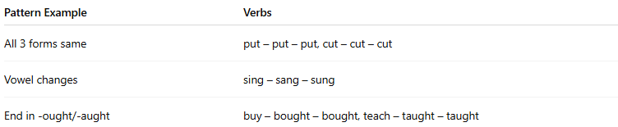

Pattern Example | Verbs
All 3 forms same | put – put – put, cut – cut – cut
Vowel changes | sing – sang – sung
End in -ought/-aught | buy – bought – bought, teach – taught – taught

❗ Irregular Verbs Must Be Memorized!
# Source: AI Source: Provided by: [Data Path: Persons Table -> ID Column: 1, Name_En Column: Motasem Essam] -> From: [Chatgpt (GPT-4-turbo)] on [7/27/2025]
There is no fixed rule, so learners usually learn them by practice and exposure.

✅ Summary Table:
# Source: AI Source: Provided by: [Data Path: Persons Table -> ID Column: 1, Name_En Column: Motasem Essam] -> From: [Chatgpt (GPT-4-turbo)] on [7/27/2025]
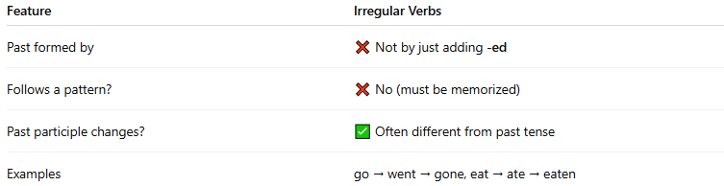
Feature | Irregular Verbs
Past formed by | ❌ Not by just adding -ed
Follows a pattern? | ❌ No (must be memorized)
Past participle changes? | ✅ Often different from past tense
Examples | go → went → gone, eat → ate → eaten

